Lab6 - Guideline

Topics
- DHCP
- NAT

- DHCP
  - DHCP IP Lease Process: Discover, Lease Offer, Lease Request, Lease Acknowledgement
  - Scope, Address Range, Reservation/Exclusion
  - Superscopes
  - Relay agent
  - DHCP on Windows Server 2008: http://www.windowsnetworking.com/articles-tutorials/windows-server-2008/How-to-Install-Configure-Windows-Server-2008-DHCP-Server.html

- Configure the pool name  Router(config)# ip dhcp pool name  - Configure the addresses(specify the network address for the users to get addresses from)  Router(dhcp-config)# network network-number [mask|prefix-length]  - Setting up the Domain Name for the Client (Address of the DNS server)  Router(dhcp-config)# dns-server address [address2 ...address5]  - Configuring the Default Router (Gateway) for the Client (!the default router has to be on the same subnet as the DHCP client)  Router(dhcp-config)# default-router address  - Configuring lease duration  Router(dhcp-config)#lease Days Hours Minutes  - Exclude IP addresses  Router(config)#ip dhcp excluded-address start_address end_address  (Exclude IP addresses that where statically assigned) | Example:  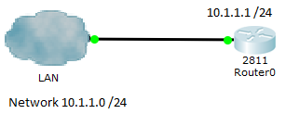  Router0(config)# ip dhcp pool LAN_IP  Router0(dhcp-config)# network 10.1.1.0 255.255.255.0  Router0(dhcp-config)# dns-server 10.1.1.2  Router0(dhcp-config)# default-router 10.1.1.1  Router(config)#ip dhcp excluded-address 10.1.1.1 10.1.1.2

- NAT
  - Purpose
  - NAT table
  - NAT types

NAT generally only translates IP addresses on a 1:1 correspondence between publicly exposed IP addresses and privately held IP addresses

Static NAT is a permanent one-to-one mapping between an inside address and an outside address
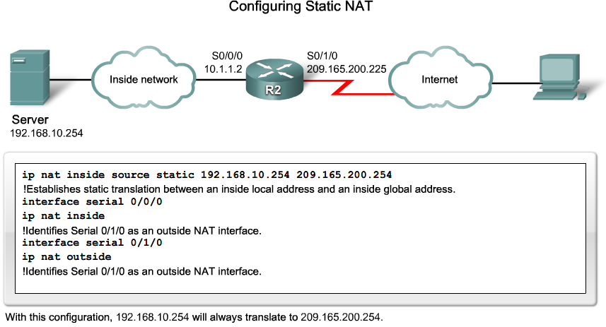

Dynamic NAT maps private IP addresses to public addresses.
- public IP addresses come from a NAT pool
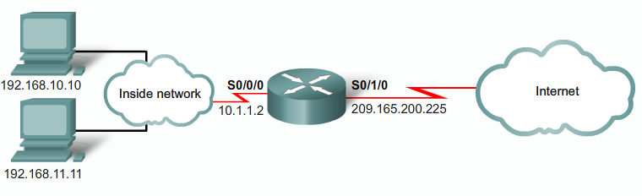
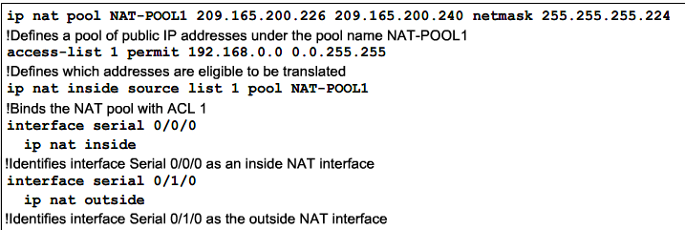

OBS: The access list can have several permit commands
NAT overloading (sometimes called Port Address Translation or PAT) maps multiple private IP addresses to a single public IP address or a few addresses
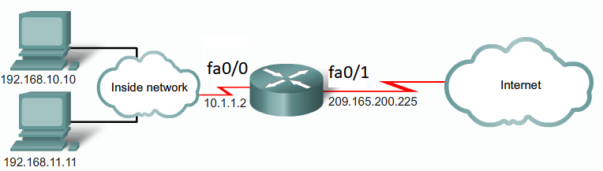
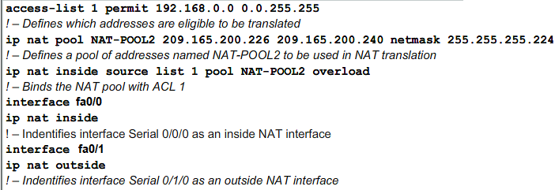

OBS: The access list can have several permit commands

Verify NAT translations:
Router#show ip nat translations
Laboratory test configuration:

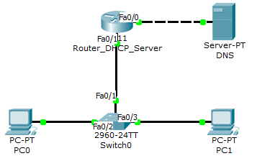

Device |  | IP address | Subnet mask | Default Gateway | DNS address
Router | Fa0/0 | 193.1.1.1 | 255.255.255.0 | - | -
Router | Fa0/1 | 172.16.2.1 | 255.255.255.0 | - | -
PCs |  | Dynamic (DHCP) | Dynamic (DHCP) | Dynamic (DHCP) | Dynamic (DHCP)
DNS Server |  | 193.1.1.2 | 255.255.255.0 | 193.1.1.1 | -

NAT Public IP Range | 193.1.1.10 – 193.1.1.15

Test the connectivity.
- ping <target IP> and tracert <target IP>
- Verify NAT translations:
Router#show ip nat translations

